OpenMP

- The OpenMP (Open Multi-Processing) is an application programming interface (API) that supports multi-platform shared memory multiprocessing programming in C/C++ and Fortran on many architectures, including Unix and Microsoft Windows platforms.
- It consists of a set of compiler directives, library routines, and environment variables that influence run-time behavior.
- OpenMP is a portable, scalable model that gives programmers a simple and flexible interface for developing parallel applications for platforms ranging from the desktop to the supercomputer.
- An application built with the hybrid model of parallel programming can run on a computer cluster using both OpenMP and Message Passing Interface (MPI).
OpenMP: shared memory
MPI: distributed memory

OpenMP components
- Compiler Directive:
A compiler directive in C/C++ is called a pragma (pragmatic information). It is a preprocessor directive, thus it is declared with a hash (#). Compiler directives specific to OpenMP in C/C++ are written in codes as follows:
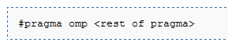
- Syntax:-
#pragma omp construct [clause [clause]…]

- Sample program: hello world
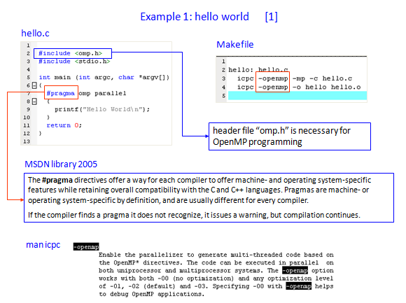
- Environment Variables:
One can selectively change storage attributes for constructs using the following clauses:
1.Shared 2.Private 3.First Private
The final value of a private inside a parallel loop can be transmitted to the shared variable outside the loop with: lastprivate.

Private Clause:
- private(var) creates a new local copy of var for each thread.
- The value is uninitialized.
- In OpenMP 2.5 the value of the shared variable is undefined after the region.
- Example:
void wrong()
{
int tmp = 0;
#pragma omp for private(tmp)
for (int j = 0; j < 1000; ++j)
tmp += j; //tmp was not initialized
printf(“%d\n”, tmp); //tmp:0 in 3.0,unspecified in 2.5
}

First Private Clause:
- Firstprivate is a special case of private.
- Initializes each private copy with the corresponding value from the master thread.
- Example:
void useless()
{
int tmp = 0;
#pragma omp for firstprivate(tmp)
for (int j = 0; j < 1000; ++j)
tmp += j; //Each thread gets its own tmp with an initial value of 0
printf(“%d\n”, tmp); //tmp is defined as its value at the “last sequential”
//iteration (i.e., for j=999)

}

Default Clause(Shared):
- The default storage attribute is DEFAULT(SHARED) (so no need to use it)
- Exception: #pragma omp task
- SHARED ( list )
- All variables in list will be considered shared.
- Every openmp thread has access to all these variables

OpenMP Programming Model.(Fork and Join Model)
- OpenMP programs start with a single thread; the master thread (Thread #0)
- At start of parallel region master creates team of parallel ”worker” threads (FORK)
- Statements in parallel block are executed in parallel by every thread
- At end of parallel region, all threads synchronize, and join master thread (JOIN)
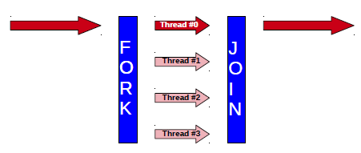

Creation of Threads

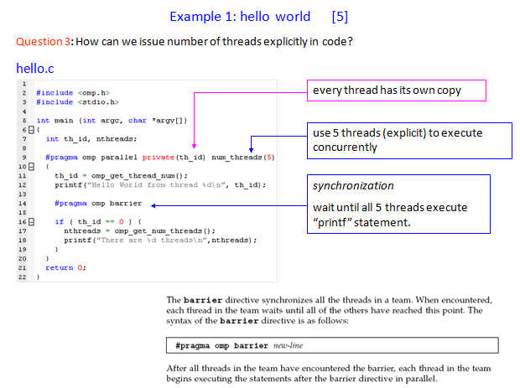
- The number of threads in a parallel region is determined by the following factors, in order of precedence:
- evaluation of the IF clause
- setting of the NUM_THREADS clause
- use of the omp_set_num_threads() library function
- setting of the OMP_NUM_THREADS environment variable
- implementation default - usually the number of CPUs on a node,
though it could be dynamic.
- Threads are numbered from 0 (master thread) to N-1.
- Master thread always has id 0

- Number of openMP threads can be set using:
-Environmental variable OMP_NUM_THREADS
-Runtime function omp_set_num_threads(n)
- Other useful function to get information about threads:
-Runtime function omp_get_num_threads()
Returns number of threads in parallel region
Returns 1 if called outside parallel region
-Runtime function omp_get_thread_num()
Returns id of thread in team
Value between [0,n-1] // where n = #threads

Synchronization concept
- Synchronization is used to impose order constraints and to protect access to shared data
- OpenMP programs use shared variables to communicate. We need to make sure these variables are not accessed at the same time by different threads.OpenMP provides a number of directives for synchronization.

High level synchronization:
- Critical
- Atomic
- Barrier
- Ordered

Low level synchronization:
- Flush
- Lock

Critical:
This Directive makes sure that only one thread can execute the code in the block. If another threads reaches the critical section it will wait until the current thread finishes this critical section. Every thread will execute the critical block and they will synchronize at end of critical section.
- Introduces overhead
- Serializes critical block
- If time in critical block relatively large → speedup negligible
Atomic:
This Directive is very similar to the CRITICAL directive. Difference is that ATOMIC is only used for the update of a memory location. Sometimes ATOMIC is also referred to as a mini critical section.
- Block consists of only one statement.
- Atomic statement must follow specific syntax.
Barrier:
BARRIER will enforce every thread to wait at the barrier until all threads have reached the barrier.BARRIER is probably the most well known synchronization mechanism;
explicitly or implictly. The following omp directives we discussed before include an implicit barrier:
-!$ OMP END PARALLEL
-!$ OMP END DO
-!$ OMP END SECTIONS
-!$ OMP END SINGLE
-!$ OMP END CRITICAL

Advantages of openMP.
- Applications are relatively easy to implement.
- Low latency, high bandwidth.
- Allows run time scheduling, dynamic load balancing.
- Both fine and course grain parallelism are effective.
- Implicit communication.
- Easy to Instrument (and check), fast learning curve
- Parallelism can be implemented incrementally
- Allows for coarse-grained or fine-grained parallelism –
- Widely available, portable

